**4.B.4. Drug Discovery:** Configuration and Deployment of Virtual Machines for Molecular Docking Experiments

Molecular docking experiments that simulate the interaction between a ligand and a protein receptor (i.e. virtual screening) are a popular tool used among biomedical researchers for drug discovery. Previous projects using docking simulations have been done on a physical grid-computing set-up, where each node is comprised of physical hardware located at different PRAGMA sites (each with its own environment and infrastructure).

Physical grid computing can create inconsistent results in virtual docking simulations because of the heterogeneous hardware components of the compute clusters. These inconsistent results can be resolved, however, by using virtual machines in a cloud computing environment. Thus, the goal of this project was to create virtual machines with identical configurations and to deploy them in PRAGMA’s cloud testbed to emulate a completely homogeneous physical grid, thereby creating a computing environment that can yield consistent virtual screening results.

Various KVM-based virtual machines were created with different operating system configurations, compliers, and architecture platforms. Each configuration was installed with DOCK ( a popular software for docking, i.e., aligning optimally, a ligand with a protein receptor), and our team screened a set of standard ligands provided with the DOCK package. We compared the results to the results provided in the DOCK package and to the findings from a previous PRIME student’ project (Yim, et al. 2010). The configuration that yielded the same results was identified as the best configuration.

The virtual machine configuration selected had a 32-bit architecture equipped with CentOS 5.9 and gcc (GNU Compiler Collection) complier version 4.1.2. This image was then moved onto the PRAGMA cloud testbed using an AIST-prepared OpenNebula-based virtual infrastructure and UC San Diego-prepared Rocks-based virtual infrastructure. Both environments had the new pragma_boot tool available. Preliminary testing demonstrates that this virtual machine is functional, but requires some optimization. Once the virtual cluster is established on the cloud, future virtual screening research will be simplified, will produce more consistent results, and will streamline the entire virtual screening workflow.

**Participants:** PRIME 2013: Kevin Lam, Karen Rodriguez; UCSD: Jason H. Haga, Nayda Williams; NAIST: Kohei Ichikawa

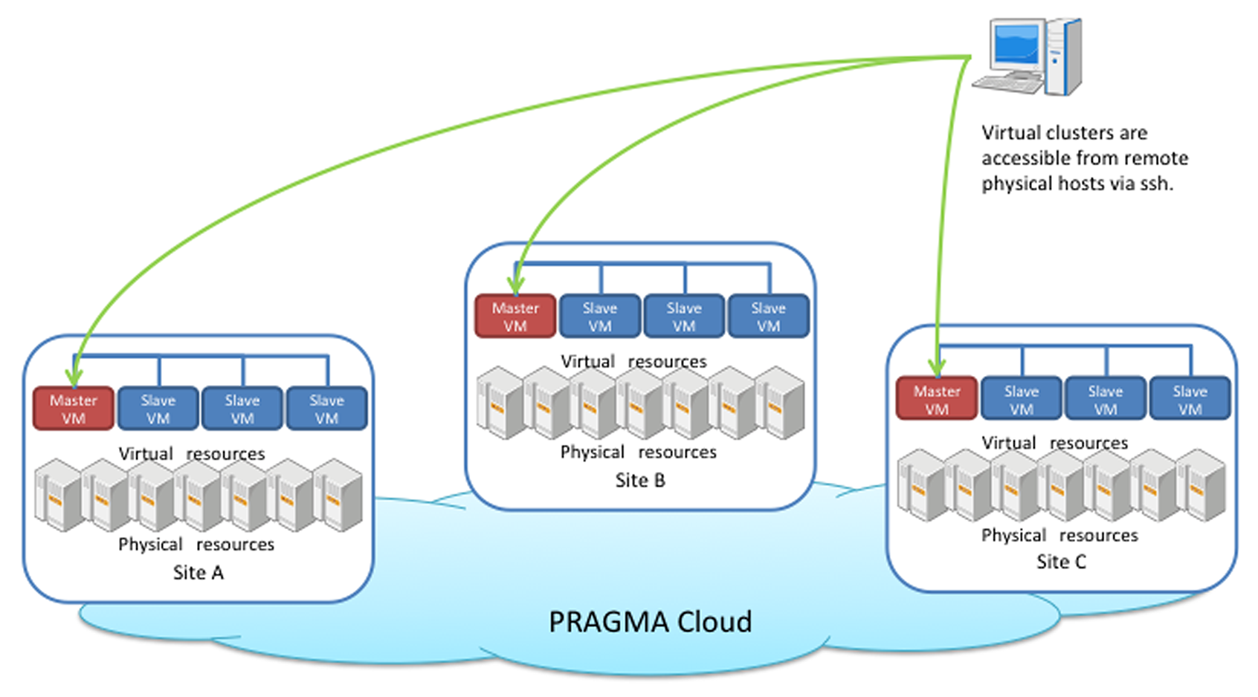

Figure XX – Diagram illustrating the resource layers in the virtualized workflow.